Elks Launch Campaign to Support Pearl Harbor
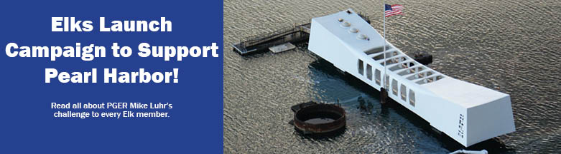
At the 2019 Elks National Convention in St. Louis, outgoing Grand Exalted Ruler Mike Luhr issued a challenge to the Elks members to raise funds for the Pearl Harbor National Memorial in Hawaii.
“I ask you then, will your Lodges and Members support the idea of making sure the memories of our veterans, passed and living, are kept with us for the years to come, and make sure the history of that ‘Day in Infamy’ is recorded so our great great-grandchildren will be able to see where our country has been?”
During their travels throughout the country, Barbara and Mike Luhr visited the Pearl Harbor National Memorial in Hawaii, in awe of the veterans who were aboard the USS Arizona that fateful day. And yet some of the displays and signage at the memorial were not as expected. They were old, weather-beaten and outdated.
They wondered if the Elks could play a part in helping to improve this memorial. That idea soon became reality, and the Elks are now partnering with the Pacific Historical Parks, a WWII focused 501(c)(3) tax-exempt public benefit organization that oversees the Pearl Harbor National Memorial.
With contributions from Elks across the country, we can preserve, restore and modernize the USS Arizona Memorial.
All funds raised will be used to:
- Replace old, faded and peeling outdoor exhibits along Pearl Harbor National Memorial’s perimeter.
- Upgrade current static displays with digital exhibits, build new interactive displays to engage children, and modernize the Pearl Harbor museums with iPads and touch screens.
- Fabricate and install new exhibits, displays, programs, and software to better educate and serve all museum visitors.
Our ultimate goal is to raise $783,000, or a dollar per member, to truly help preserve history, perpetuate peace and reconciliation and ensure that the memories of our veterans, passed and living, are never forgotten. These contributions will help honor the service and dedication of Americans whose profound contributions to our nation should never be orgotten, so that generations to come will know and appreciate the enormous sacrifices of the Greatest Generation.
Together, the Elks can accomplish this goal. Will you help?
Make a donation today at enf.elks.org/phc!

